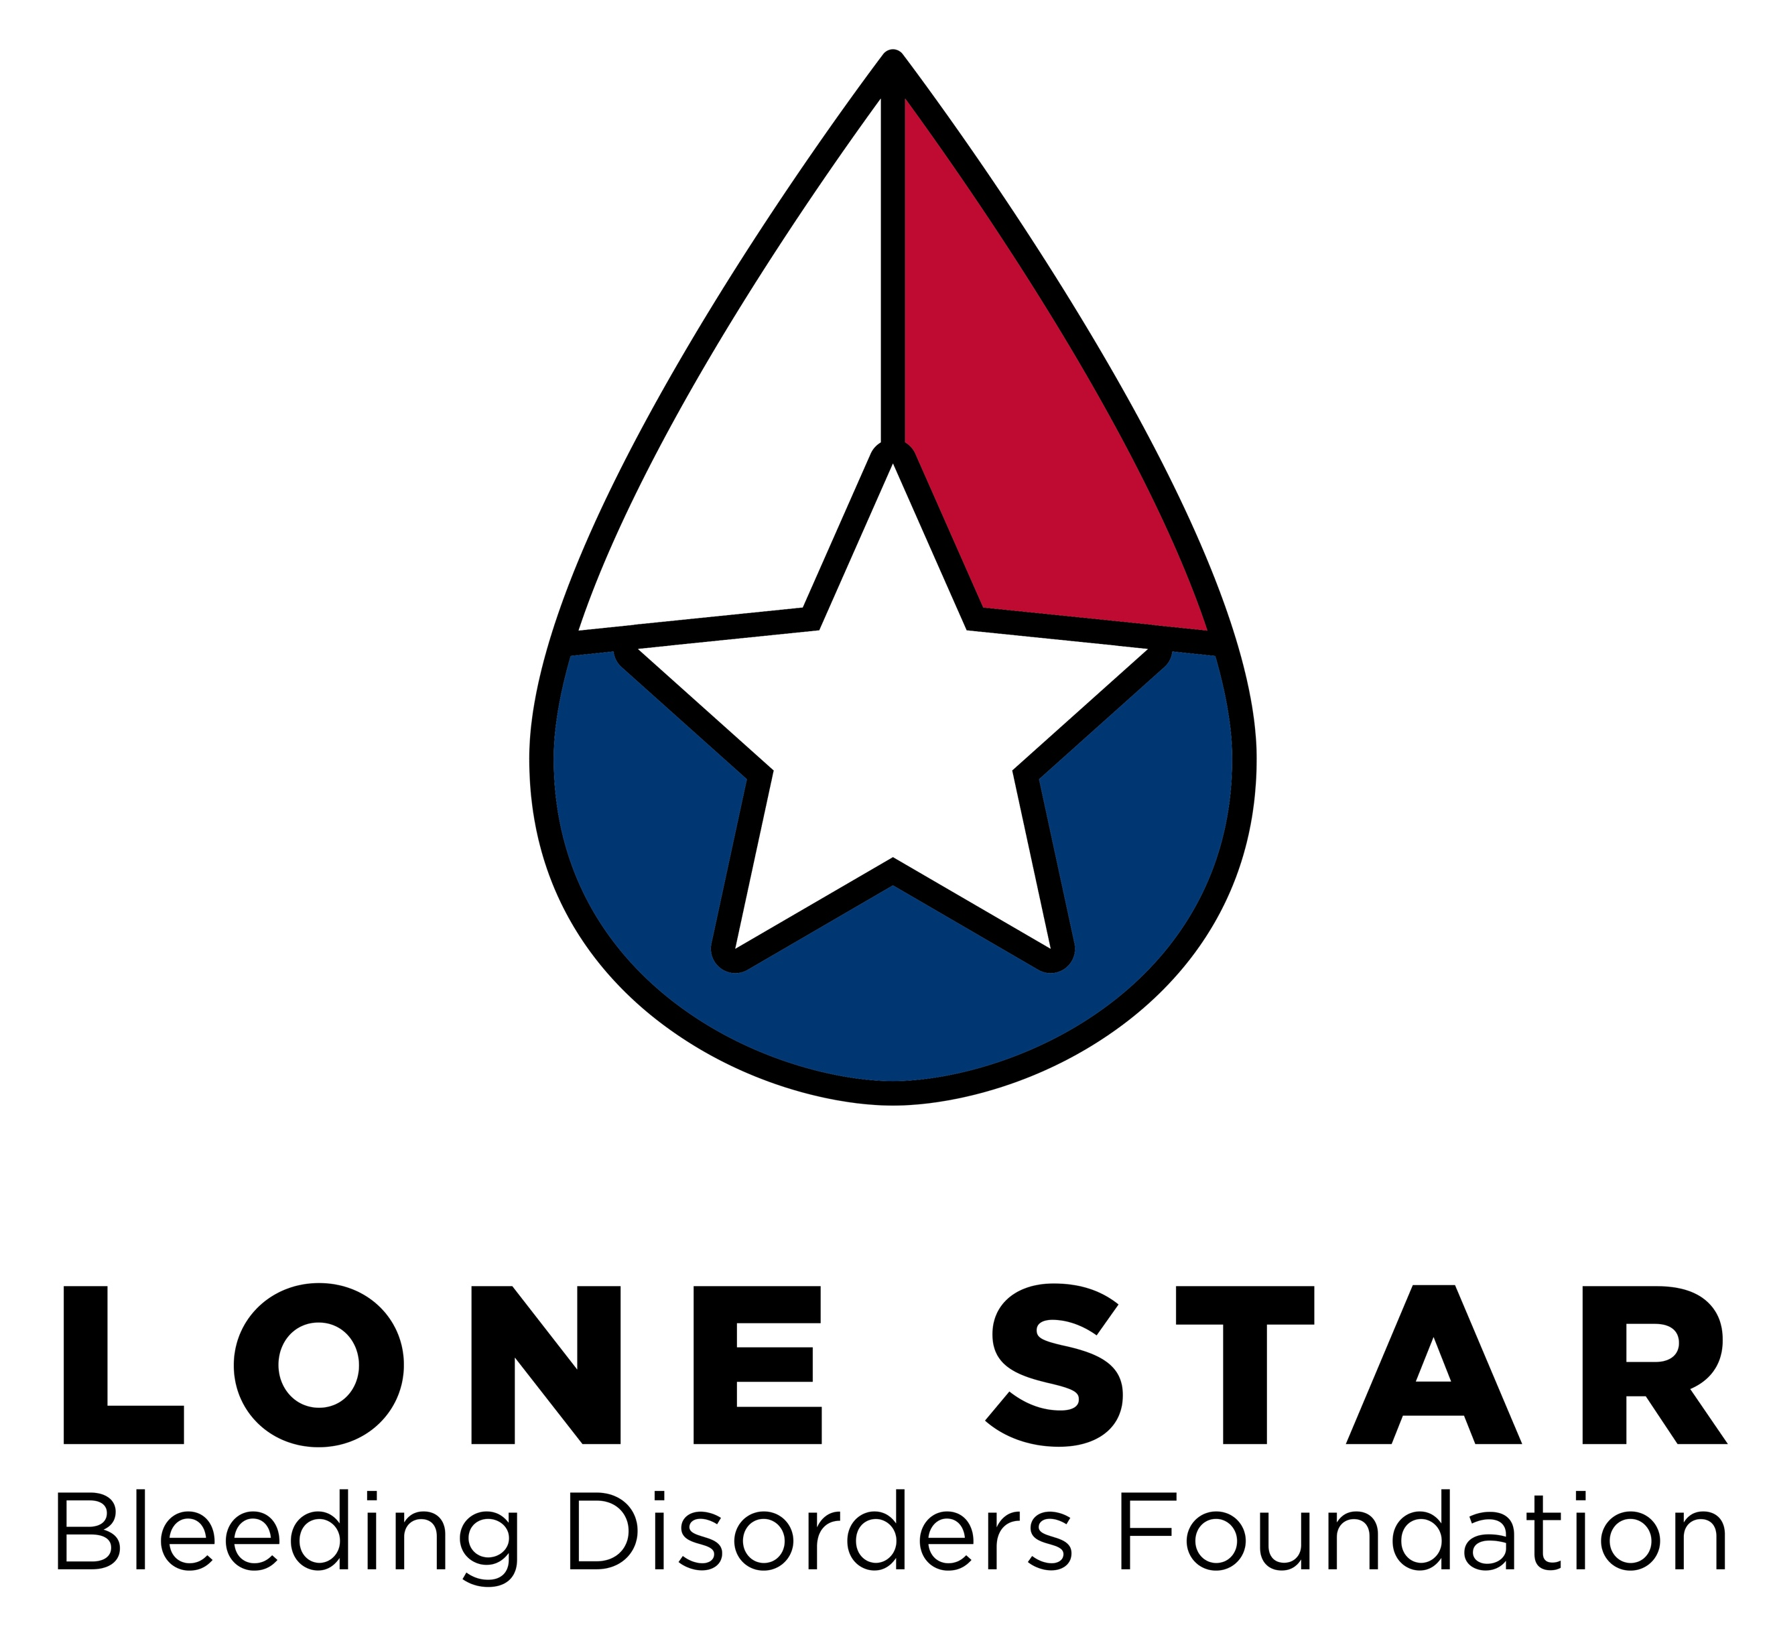

**Lone Star Bleeding Disorders Foundation**

**2022 HFA Symposium Family Scholarship Application**

The Hemophilia Federation of America’s Annual Symposium is a great opportunity for families with bleeding disorders, and this year it is right here in **San Antonio, Texas, April 20-23, 2022.** There are educational sessions for everyone in the family, and the Exhibit Hall is a great place to learn about all the products and services available.

We are very grateful to Hemophilia Federation of America for providing us a block of rooms so we may invite even more families to this exciting event with our Family Scholarships!

The Chapter and Hemophilia Federation of America will cover:

*Registration Fees for your immediate household/family

*Hotel for duration of event

*Mileage to hotel (you must provide mapquest mileage to and from your home to hotel)

*Self-parking at the hotel. We will not cover valet parking.

You will be responsible for:

*Any meals not provided at the conference (many meals are provided, but any additional meals or snacks outside of those provided times, snacks, etc, will be your responsibility.)

*Attending sessions. Youth and Teens will be responsible for attending sessions relative to them as well.

*Having a great time!

Due to the COVID-19 pandemic, HFA has put in place strict protocols to keep all attendees safe. Please visit <https://www.hfasymposium.org/faqs/>. There is a place on the application to sign that you have read and are in agreement with all protocols put in place. **Please read before applying for this scholarship.** All attendees 5 years and older must be fully vaccinated, and masks will be required. Please visit the website above for all details regarding safety protocols and guidelines for attendance.

In order to apply for this scholarship, you must fill this application out COMPLETELY. Incomplete applications will not be considered. Please fill out all registration information, answer all questions, and complete the essay. Please make multiple copies for additional adults and youth!

**Applications must be submitted by February 20, 2022. Please email to Heidi at [hhensley@lonestarbleedingdisorders.org](mailto:hhensley@lonestarbleedingdisorders.org) or fax to 832-383-4601

**Registrant Information**

Family/Household Name ______________________________________________

Adult #1 Full Name __________________________________________________

Address ___________________________________________________________

City ________________________________ State __TX___ Zip ______________

Primary Phone ______________________________________________________

Email ______________________________________________________________

Date of Birth _____________________ Age as of April 20, 2022 _____________

Do you have a bleeding disorder, and if so, which one? ______________________

Attendee # 2 Name ___________________________________________________

Date of Birth _____________________ Age as of April 20, 2022 _____________

Do you have a bleeding disorder, and if so, which one? ______________________

Attendee # 3 Name ___________________________________________________

Date of Birth _____________________ Age as of April 20, 2022 _____________

Do you have a bleeding disorder, and if so, which one? ______________________

Attendee # 4 Name ___________________________________________________

Date of Birth _____________________ Age as of April 20, 2022 _____________

Do you have a bleeding disorder, and if so, which one? ______________________

Attendee # 5 Name ___________________________________________________

Date of Birth _____________________ Age as of April 20, 2022 _____________

Do you have a bleeding disorder, and if so, which one? ______________________

Which HTC or Hematologist do you use for your care?

Have you or any members of your family attended HFA Symposium in the past?

Yes No

If yes, what do you remember most about that Symposium? What did you learn?

________________________________________________________________________

________________________________________________________________________

________________________________________________________________________

________________________________________________________________________

| **On a scale of 1 to 4, please respond to the grid below how you feel in relation to you/your immediate family member(s) having a bleeding disorder:** **\*** | | | | |
| --- | --- | --- | --- | --- |
|  | Never | Rarely | Sometimes | Often |
| **I feel alone in relation to the bleeding disorder** | 1 | 2 | 3 | 4 |
| **I feel I have support around the bleeding disorder from medical providers** | 1 | 2 | 3 | 4 |
| **I feel I have support around the bleeding disorder from family** | 1 | 2 | 3 | 4 |
| **I feel I have support around the bleeding disorder from friends** | 1 | 2 | 3 | 4 |
| **I feel I have support around the bleeding disorder from my NHF Chapter** | 1 | 2 | 3 | 4 |
| **I feel confused about the bleeding disorder medically** | 1 | 2 | 3 | 4 |
| **I feel confused about how the bleeding disorder will impact our lives** | 1 | 2 | 3 | 4 |
| **I feel there are people I can turn to about the bleeding disorder** | 1 | 2 | 3 | 4 |

|  | Not Confident | Somewhat Confident | Confident | Very Confident |
| --- | --- | --- | --- | --- |
| **On a scale of 1 to 4, how confident do you feel in managing your/your immediate family member's bleeding disorder?** | 1 | 2 | 3 | 4 |

**Essay**

Please answer the following questions in an essay of no more than 250 words:

Why do you want to attend the HFA’s 2022 Symposium, and how will you take the information you learned at Symposium back to your family and community?

**Children’s Camp and Teen Program Information:**

Childcare (Ages 2 mos to 4 years) Onsite childcare for children under 5 years. More info to come.

Youth Program (Ages 5-12): The youth program is a two and a half day connected program of camp-like activities and relationships. The program will include arts and crafts, recreation and adventure, science and bleeding disorders education, and outdoor living skills and nature. Lunch and snacks will be provided. Supervision will be provided by camp professionals from across the country.

Teen Program (Ages 13-17): The teen program will provide fun and engaging opportunities for teens from around the country to connect, share experiences, and give back to the bleeding disorders community. The program will be interactive, and age appropriate. Lunch and snacks will be provided. Supervision will be provided by camp professionals with experience providing teen programming.

**Code of Conduct:**

Our Symposium is a fun and safe learning environment designed to increase interaction and engagement, and foster a sense of connectivity and collaboration among attendees. We value the participation of each attendee and endeavor to deliver an enjoyable and fulfilling experience. Attendees are expected to conduct themselves with integrity, courtesy and respect for others at all session and events. All attendees are required to observe the following Code of Conduct.

Some discussions over the course of Symposium sessions may include disclosure of an individual’s personal information (e.g health or financial information). All participants are asked to help protect the integrity of these sessions and to keep confidential any such information discussed. All participants are also reminded to refrain from steering conversations in the direction of bleeding disorders business (to or away from specific companies, products, or providers).

HFA will not tolerate harassment in any form and is dedicated to providing a safe and welcoming experience for all attendees regardless of gender, sexual orientation, disability, physical appearance, race, or religion. All participants must conduct themselves in a manner that is appropriate for and inclusive of people of diverse backgrounds and cultures. Sexual or derogatory language and imagery is not appropriate. Do not insult or defame attendees, speakers, or exhibitors. Participants violating these rules will be asked to leave.